DOCUMENT CREATION AND FORMATTING

Ex. No.: 1(a) Date: 27.11.2020

EXERCISE NAME: Document Creation and Formatting

AIM:

To create a new document and format the text using any office automation tool

PROCEDURE: (Using Microsoft Office)

Step 1: To open a new word document select Start-> Microsoft office-> Microsoft word

Step 2: For the Text Formatting

Bold – Home-> Bold or (ctrl + b)

Italic – Home-> Italic or (ctrl + i) Underline – Home-> Underline or (ctrl + u) Cut – Home->cut or (ctrl + x)
Copy – Home-> Bold or (ctrl + c)

Paste – Home-> Bold or (ctrl + v)

Step 3: For the Text Alignment Left alignment – ctrl+l Right alignment – ctrl+r Center alignment – ctrl+e Justify alignment – ctrl+j

Step 4: For Page Setup

Margin setup – Page layout-> Margins

Page orientation – Page layout -> Orientation

Paper size – Page layout -> Size

Split the text into more columns – Page layout->Columns

Step 5: To insert a table select Insert->Table->Insert Table

Step 6: To insert a picture select Insert->Picture

Step 7: To insert a shapes select Insert->Shapes

Step 8: To insert a page number select Insert->Page Number

Step 9: To insert symbol select Insert->symbol

Step 10: To insert equations select Insert->Object->Microsoft Equation

Step 11: To save the document select File->Save

Step 12: To open an existing document select File->Open

Step 13: To close the document select File->Exit

SPREAD SHEET CREATION AND CALCULATION

Ex. No.: 2(a) Date: 04/12/2020

EXERCISE NAME: Spread Sheet Creation And Calculation

AIM:

To create a new spread sheet and perform calculation using any office
automation tool

PROCEDURE: (Using Microsoft Office)

Step 1: To open a new spreadsheet select Start-> Microsoft office-> Microsoft Excel
Step 2: To calculate the total use the function =sum(cell range)

Step 3: To calculate the average use the function =average(cell range) Step 4: To calculate the minimum value use the function = min(cell range) Step 5: To calculate the maximum value use the function =max(cell range)
Step 6: To ceil the floating point value use the function =ceiling(cell,significance)

Step 7: To round off the floating point value use the function

=round(cell, number of digits)

Step 8: To count the number of cells use the function=count(cell range)

Step 9: To count the number of cells with condition use the function

=countif(cell range, criteria)

Step 10: To insert a chart select Insert->Chart

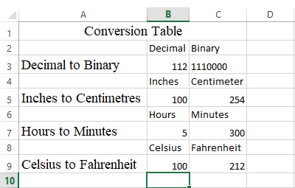

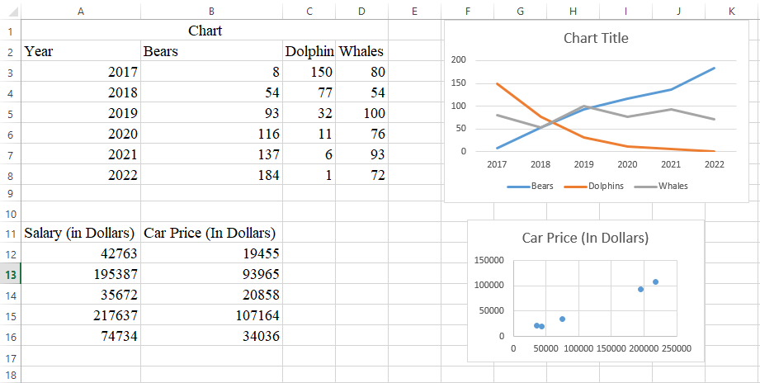

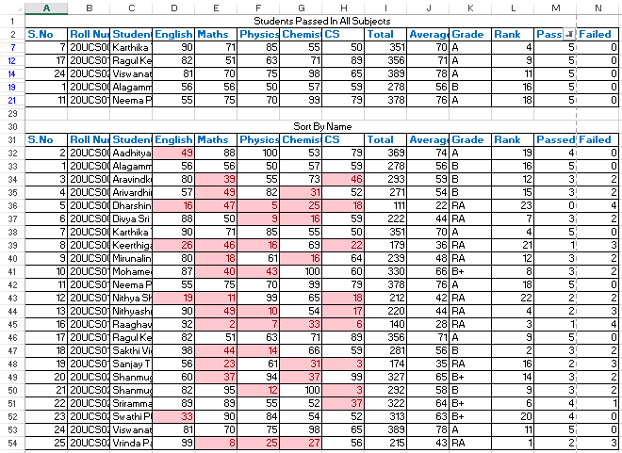

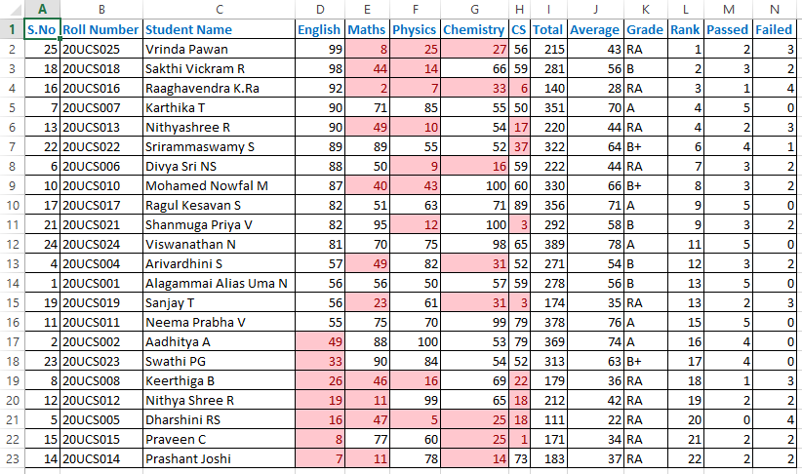
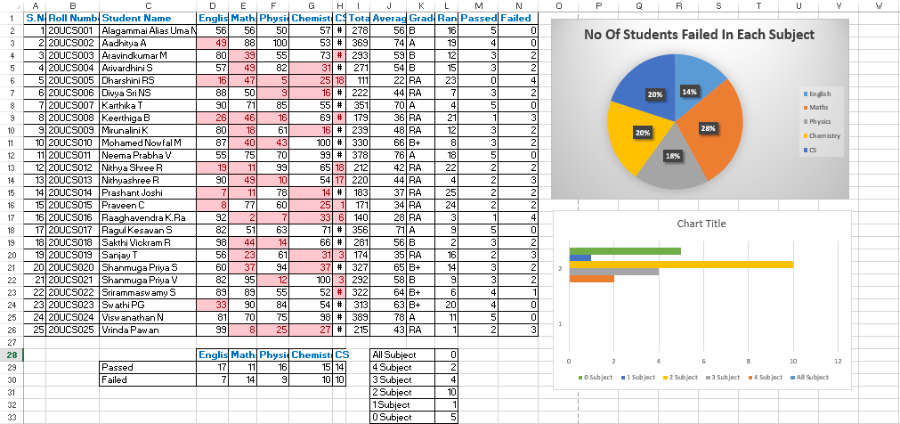

POWER POINT PRESENTATION

Ex. No.: 3(a) Date: 11/12/2020

EXERCISE NAME: Power Point Creation and Presentation

AIM:

To create a new power point presentation using any office automation tool

PROCEDURE: (Using Microsoft Office)

Step 1: To open a new power point presentation select Start-> Microsoft office-> Microsoft PowerPoint
Step 2: To create a new slide select Home->Slide (ctrl + m)

Step 3: To insert a video select Insert->Video

Step 4: To insert a audio select Insert->Audio

Step 5: To change the theme of the slide select Design->Office Theme

FLOWCHART

Ex. No.: 4(a) Date: 18/12/2020

EXERCISE NAME: Flowchart for area of a circle

AIM:

To draw the flowchart for area of a circle

ALGORITHM:

Area of a circle Step 1: Start
Step 2: Read the value of r

Step 3: Calculate area = 3.14*r*r Step 4: Print the value of area Step 5: Stop

Flowchart
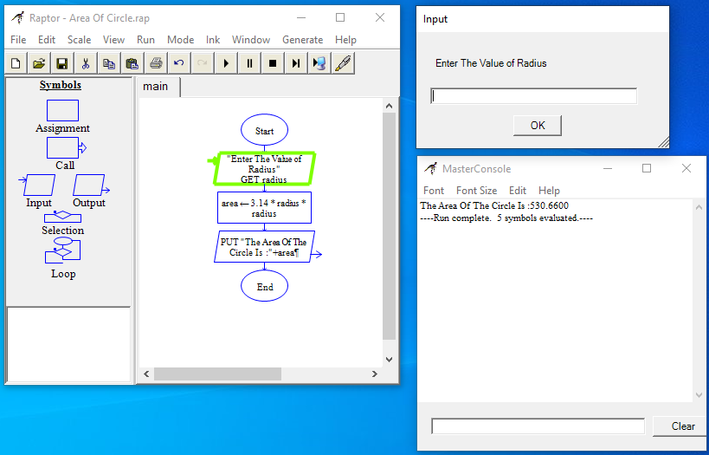

Result
Thus the flowchart is drawn successfully using raptor tool.

Ex. No.: 4(b) Date: 18/12/2020

EXERCISE NAME: Flowchart For Biggest Among Two Numbers

AIM:

To draw the flowchart for biggest among two numbers

ALGORITHM:

Biggest among two numbers Step 1: Start
Step 2: Read two numbers for A and B

Step 3: Compare the value of A and B. If A is greater goto Step 4 else goto Step 5

Step 4: Output “A is greatest” Step 5: Output “B is greatest” Step 6: Stop

Flowchart
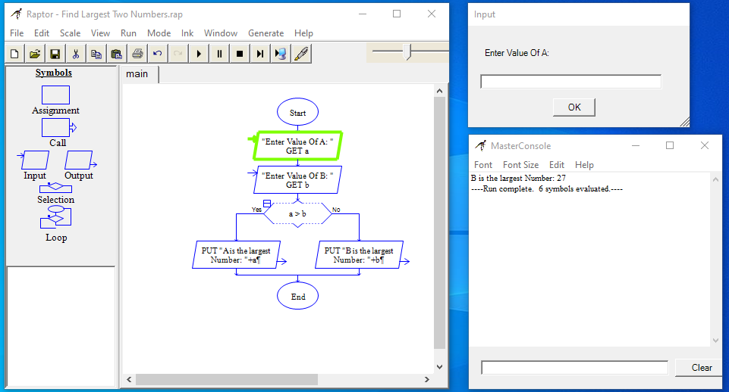

Result
Thus the flowchart is drawn successfully using raptor tool.

Ex. No.: 4(c) Date: 18/12/2020

EXERCISE NAME: Flowchart For Grade Of The Students

AIM:

To draw the flowchart for compute the grade of the students

ALGORITHM:
Grade of the student Step 1: Start
Step 2: Read five integer marks for mark1, mark2, mark3, mark4, mark5
Step 3: Calculate total=mark1+mark2+mark3+mark4+mark5
Step 4: Print total
Step 5: Calculate avg=total / 5
Step 6: Print avg
Step 7: Calculate grade=avg /10
Step 8: Print grade
Step 9: Check if grade>9 if it is true goto Step 10 else goto Step 11
Step 10: Print O grade
Step 11: Check the condition grade>8 if it is true goto Step 12 else goto Step 13
Step 12: Print A+ grade
Step 13: Check the condition grade>7 if it is true goto Step 14 else goto Step 15
Step 14: Print A grade
Step 15: Check the condition grade>6 if it is true goto Step 16 else goto Step 17
Step 16: Print B grade Step 17: Print Reapper Step 18: Stop

Flowchart
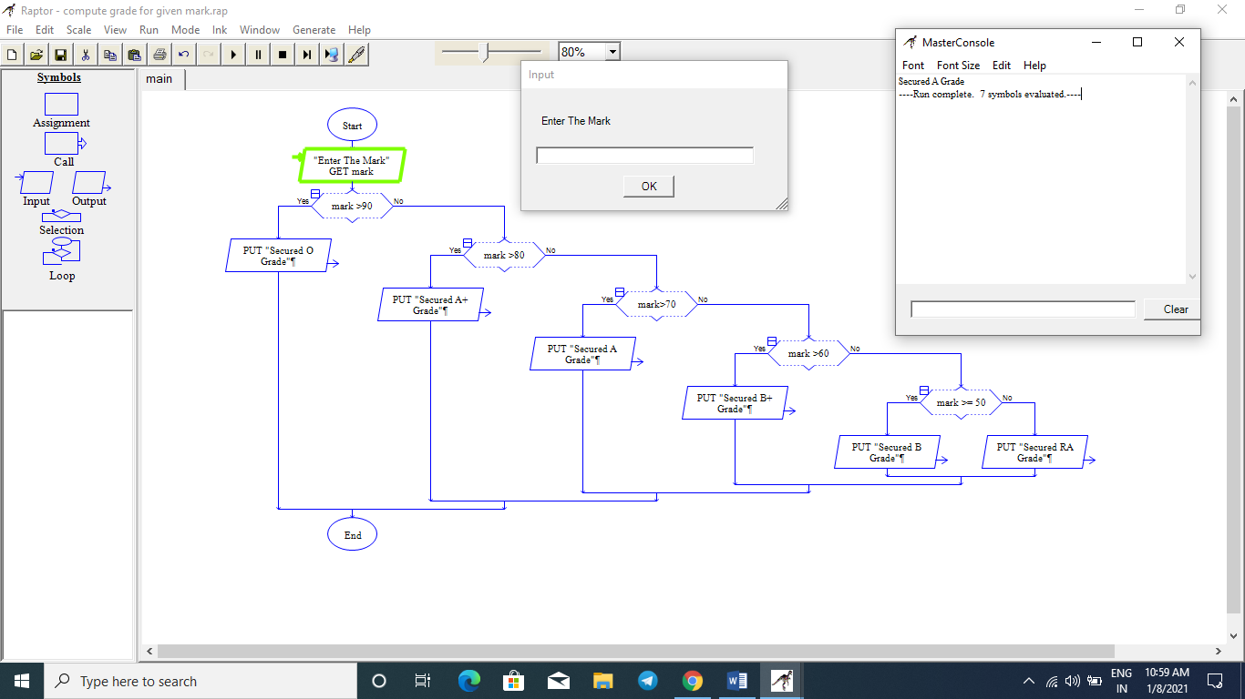

Result
Thus the flowchart is drawn successfully using raptor tool.

Ex. No.: 4(d) Date: 18/12/2020

EXERCISE NAME: Flowchart For Sum And Average Of N numbers

AIM:

To draw the flowchart to find the sum and average of N numbers

ALGORITHM:

Sum and Average of N numbers Step 1: Start
Step 2: Read the value of n

Step 3: Assign the value of sum=0 and i=1

Step 4: Check the condition (i<=n). If the condition is true goto Step 5 else goto Step 7
Step 5: Assign sum = sum + i

Assign i = i +1

Step 6: Repeat the Step 5 until the condition is satisfied

Step 7: Compute avg = sum / n

Step 8: Print the value of sum and avg

Step 9: Stop

Flowchart
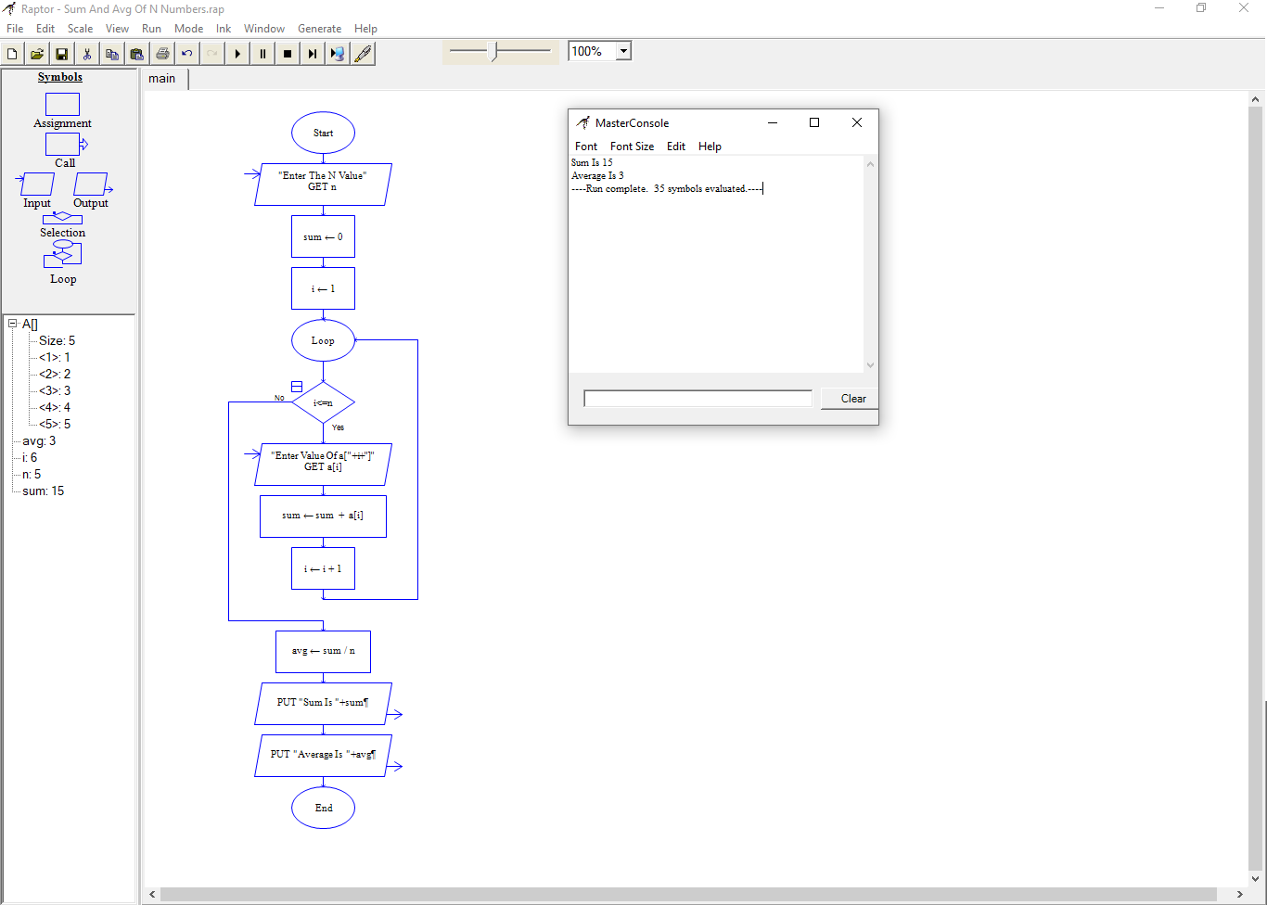

Result
Thus the flowchart is drawn successfully using raptor tool.

C PROGRAMS USING I/O STATEMENTS AND EXPRESSIONS

Ex. No.: 5(a)(i) Date: 08/01/2021

PROGRAM NAME: Find The Area And Volume Of Shapes

AIM:

To Write a C Program to find the area and volume of shapes

ALGORITHM:

Area of a Circle Step 1: Start
Step 2: Read the value of r

Step 3: Calculate area = 3.14*r*r Step 4: Print the value of area Step 5: Stop

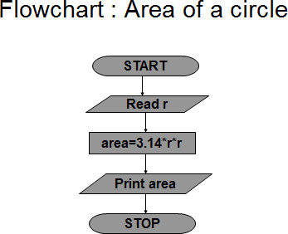

Program
#include <stdio.h>
int main()
{
float r;
printf("Enter The Radius Of A Circle: ");
scanf("%f", &r);
printf("Area = %.2f \n", 3.14*r*r);
return 0;
}
Output
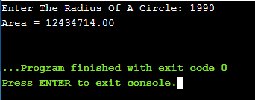

Ex. No.: 5(a)(ii) Date: 08/01/2021

ALGORITHM:

Area of a Rectangle Step 1: Start
Step 2: Read the value of length and breadth Step 3: Calculate area = length * breadth Step 4: Print the value of area
Step 5: Stop

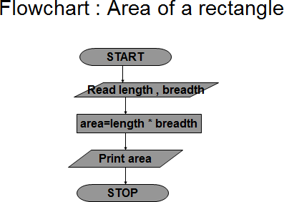
Program
#include <stdio.h>
int main()
{
float b, l;
printf("Enter Length Of The Rectangle: ");
scanf("%f", &l);
printf("Enter Breadth Of The Rectangle: ");
scanf("%f", &b);
printf("Area = %.2f \n", l*b);
return 0;
}
Output
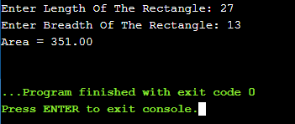

Ex. No.: 5(a)(iii) Date:

ALGORITHM:

Area of a Triangle Step 1: Start
Step 2: Read the value of base and height Step 3: Calculate area = 0.5 * base * height Step 4: Print the value of area
Step 5: Stop

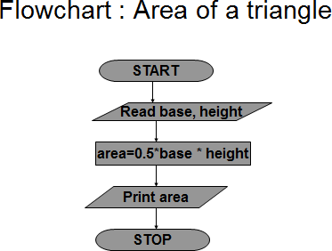

Program
#include <stdio.h>
int main()
{
float b, h;
printf("Enter Breadth Of The Triangle: ");
scanf("%f", &b);
printf("Enter Height Of The Triangle: ");
scanf("%f", &h);
printf("Area = %.2f \n", (b*h)/2);
return 0;
}
Output
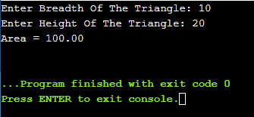

Ex. No.: 5(a)(iv) Date: 08/01/2021

ALGORITHM:

Area of a Square Step 1: Start
Step 2: Read the value of side Step 3: Calculate area = side * side Step 4: Print the value of area Step 5: Stop

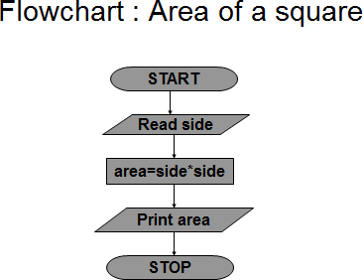

Program
#include <stdio.h>
int main()
{
float b;
printf("Enter Length Of Side Of A Square: ");
scanf("%f", &b);
printf("Area = %.2f \n", b*b);
return 0;
}
Output
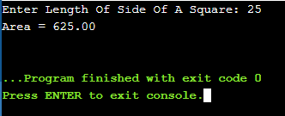

Ex. No.: 5(a)(v) Date: 08/01/2021

ALGORITHM:

Volume of a Cube Step 1: Start
Step 2: Read the value of side

Step 3: Calculate volume = side * side * side

Step 4: Print the value of volume

Step 5: Stop

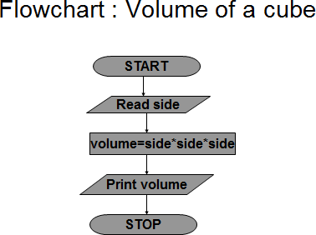

Program
#include <stdio.h>
int main()
{
float l;
printf("Enter The Edge Value Of Cube: ");
scanf("%f", &l);
printf("Volume = %.2f \n", l*l*l);
return 0;
}
Output
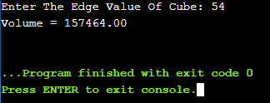

Ex. No.: 5(b) Date: 08/01/2021

PROGRAM NAME: Convert Centigrade to Fahrenheit

AIM:

To Write a C Program to convert Centigrade to Fahrenheit

ALGORITHM:

Celsius to Fahrenheit Step 1: Start
Step 2: Read the value of Celsius

Step 3: Calculate Fahrenheit = (1.8* Celsius) + 32

Step 4: Print the value Fahrenheit

Step 5: Stop

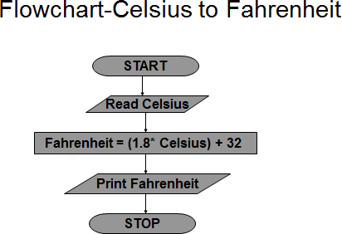

Program
#include <stdio.h>
int main()
{
float c, f;
printf("Enter temperature in Celsius: ");
scanf("%f", &c);
f = (c * 9 / 5) + 32;
printf("%.2f Celsius = %.2f Fahrenheit", c, f);
return 0;
}
Output
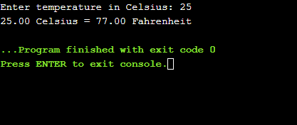

Ex. No.: 5(c) (i) Date: 08/01/2021

PROGRAM NAME: i) Swap Two Numbers Using Temporary Variable

AIM:

To Write a C Program to swap two numbers using temporary variable

ALGORITHM:

Swap using temp variable Step 1: Start the program
Step 2: Read the value of a and b

Step 3: Assign c = a

Assign a = b Assign b = c
Step 4: Print the value of a and b

Step 5: Stop

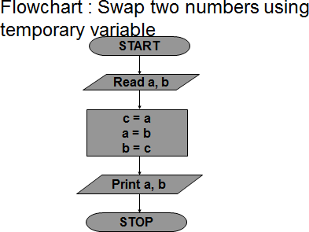

Program
#include <stdio.h>
int main()
{
int temp, x, y;
printf("Enter the Value Of X: ");
scanf("%d", &x);
printf("Enter the Value Of Y: ");
scanf("%d", &y);
printf("Before Swaping Of Two Numbers\n");
printf("X = %d ; Y = %d", x, y);
temp = x;
x = y;
y = temp;
printf("\nAfter Swaping Of Two Numbers\n");
printf("X = %d ; Y = %d", x, y);
return 0;
}
Output
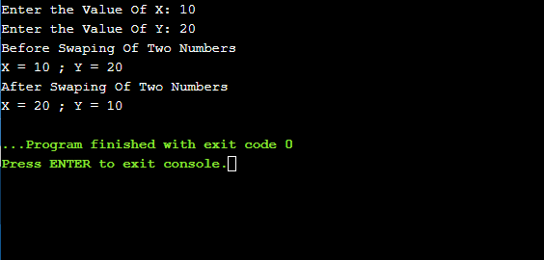

Ex. No.: 5(c)(ii) Date: 08/01/2021

PROGRAM NAME: ii) Swap Two Numbers Without Using Temporary Variable

AIM:

To Write a C Program to swap two numbers without using temporary variable

ALGORITHM:

Swap without temp variable Step 1: Start
Step 2: Read the value of a and b

Step 3: Assign a = a + b

Assign b = a - b Assign a = a - b
Step 4: Print the value of a and b

Step 5: Stop

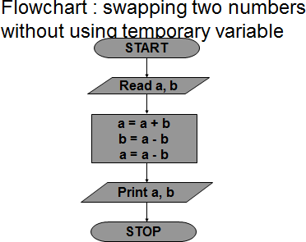

Program
#include <stdio.h>
int main()
{
int x, y;
printf("Enter the Value Of X: ");
scanf("%d", &x);
printf("Enter the Value Of Y: ");
scanf("%d", &y);
printf("Before Swaping Of Two Numbers\n");
printf("X = %d ; Y = %d", x, y);
x=x+y;
y=x-y;
x=x-y;
printf("\nAfter Swaping Of Two Numbers\n");
printf("X = %d ; Y = %d", x, y);
return 0;
}
Output

Result
Thus the C program was written and executed successfully for the following
- Find area and volume of shapes
- Convert centigrade to Fahrenheit
- Swap two numbers with and without using temporary variable

C PROGRAMS USING DECISION MAKING CONSTRUCTS

Ex. No.: 6(a) Date: 11/01/2021

PROGRAM NAME: Find The Biggest Among Two Numbers

AIM:

To Write a C Program to find the biggest among two numbers

ALGORITHM:

Biggest among two numbers Step 1: Start
Step 2: Read two numbers for a and b

Step 3: Compare the value of a and b. If a is greater goto Step 4 else goto Step 5

Step 4: Output “a is greatest” Step 5: Output “b is greatest” Sep 6 : Stop

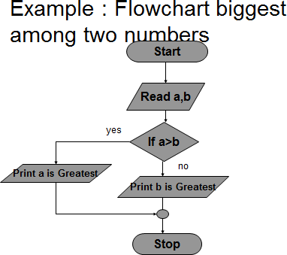
Program
#include <stdio.h>
int main()
{
int num1, num2;
printf("Enter the Value Of num1 and num2: ");
scanf("%d %d", &num1, &num2);
if(num1>num2) {
printf("%d is The Biggest Number", num1);
} else {
printf("%d is The Biggest Number", num2);
}
return 0;
}

Output
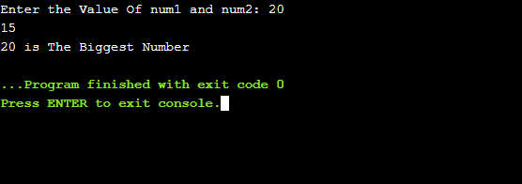

Ex. No.: 6(b) Date: 11/01/2021

PROGRAM NAME: Check The Given Year Is Leap Year Or Not

AIM:

To Write a C Program to check the given year is leap year or not

ALGORITHM:

Check the given year is Leap year or not.

Step 1: Start

Step 2: Read the value for year

Step 3: Check (year%400=0) or (year%4=0 and year%100=0), If the condition is true perform Step 4 else perform Step 5
Step 4: Print year is leap year

Step 5: Print year is not a leap year

Step 6: Stop

FLOWCHART FOR LEAP YEAR
Start
Read year
True
IS (iyear%400=0)or (iyear%100=0 and iyear%4=0)
False
Print yPerairnits
leap year.
Stop
Print year is not a leap year.

Program
#include <stdio.h>
int main()
{
int year;
printf("Enter the Year: ");
scanf("%d", &year);
if((year%4==0 && year%100!=0)||(year%400==0)) {
printf("Leap Year");
} else {
printf("Not A Leap Year");
}
return 0;
}

Output
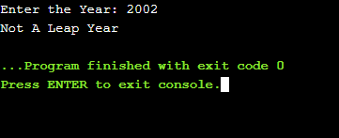
Ex. No.: 6(c) Date: 11/01/2021

PROGRAM NAME: Compute Grade For Given Marks

AIM:

To Write a C Program to compute the grade for given marks

ALGORITHM:

Grade of the student Step 1: Start
Step 2: Read five integer marks for mark1, mark2, mark3, mark4, mark5

Step 3: Calculate total=mark1+mark2+mark3+mark4+mark5

Step 4: Print total

Step 5: Calculate avg=total / 5

Step 6: Print avg

Step 7: Calculate grade=avg /10

Step 8: Print grade

Step 9: Check if grade>9 if it is true goto Step 10 else goto Step 11

Step 10: Print O grade

Step 11: Check the condition grade>8 if it is true goto Step 12 else goto Step 13

Step 12: Print A+ grade

Step 13: Check the condition grade>7 if it is true goto Step 14 else goto Step 15

Step 14: Print A grade

Step 15: Check the condition grade>6 if it is true goto Step 16 else goto Step 17

Step 16: Print B grade

Step 17: Print Reapper
True
grade
> 9
False
Print O grade
True
grade
> 8
False
Print A+ grade
True
grade
> 7
False
Print A grade
True
False
grade
> 6
Print B+ grade
True
grade
> =5
False
Print B grade
Print Reappear
Stop
total = mark1+mark2+mark3+mar4+mark5 avg=total/5

Step 18: Stop

FLOW CHART : Student Grade
Start
Read mark1,mark2,mark3,mark4,mark

Program
#include <stdio.h>
int main()
{
int mark;
printf("Enter the Mark: ");
scanf("%d", &mark);
if (mark>90) {
printf("O Grade");
} else if (mark>80) {
printf("A+ Grade");
} else if (mark>70) {
printf("A Grade");
} else if (mark>60) {
printf("B+ Grade");
} else if (mark>=50) {
printf("B Grade");
} else {
printf("Secured RA Grade");
}
return 0;
}

Output
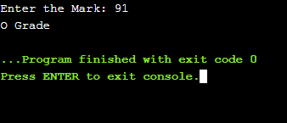
Result
Thus the C program was written and executed successfully for the following
- Find the biggest of two numbers
- Check whether the given year is leap year or not
- Compute grade for given mark

C PROGRAMS USING LOOPING CONSTRUCTS

Ex. No.: 7(a) Date: 22/01/2021

PROGRAM NAME: Find The Sum And Average Of N Numbers

AIM:

To Write a C Program to find the sum and average of N Numbers

ALGORITHM:

Sum and Average of N numbers Step 1: Start
Step 2: Read the value of n

Step 3: Assign the value of sum=0 and i=1

Step 4: Check the condition (i<=n). If the condition is true goto Step 5 else goto Step 7
Step 5: Assign sum = sum + i

Assign i = i +1

Step 6: Repeat the Step 5 until the condition satisfied

Step 7: Compute avg = sum / n

Step 8: Print the value of sum and avg

Step 9: Stop

FLOWCHART: SUM AND AVERAGE OF N NUMBERS

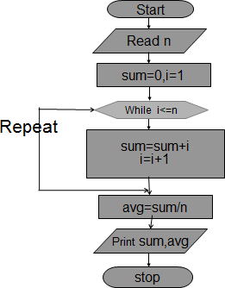

Program
#include<stdio.h>
int main() {
int i,n,Sum=0,numbers;
float Average;
printf("\nPlease Enter How many Number you want?\n");
scanf("%d",&n);
printf("\nPlease Enter the elements one by one\n");
for(i=0;i<n;++i) {
scanf("%d",&numbers);
Sum = Sum +numbers;
}
Average = Sum/n;
printf("\nSum of the %d Numbers = %d",n, Sum);
printf("\nAverage of the %d Numbers = %.2f",n, Average);
return 0;
}

Output
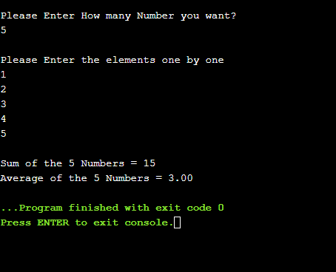
Ex. No.: 7(b) Date: 22/01/2021

PROGRAM NAME: Find the given number is Armstrong number or not

AIM:

To Write a C Program to find the given number is Armstrong number or not

ALGORITHM:

Armstrong number checking for three digits Step 1: Start
Step 2: Read the value of n

Step 3: Assign the value sum = 0, temp=n

Step 4: Check the condition n>0, If the condition is true goto Step 5 else goto Step7

Step 5: Assign rem = n % 10

Assign sum = sum + rem*rem*rem Assign n = n / 10
Step 6: Repeat the Step 5 until the condition satisfied

Step 7: Check sum = temp, If the condition is true goto Step 8 else goto Step 9

Step 8: Print Armstrong Step 9: Print Not Armstrong Step 10: Stop

Flowchart for Armstrong number Checking

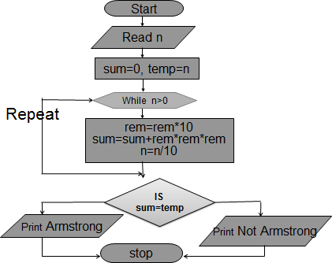

Program
#include <stdio.h>
int main() {
int num,r,sum=0,temp;
printf("Enter A Number: ");
scanf("%d",&num);
for(temp=num;num!=0;num=num/10){
r=num % 10;
sum=sum+(r*r*r);
}
if(sum==temp) {
printf("%d is an Armstrong number.\n",temp);
} else {
printf("%d is not an Armstrong number.\n",temp);
}
return 0;
}
Output
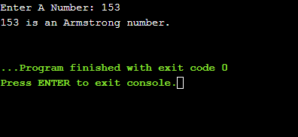

Result
Thus the C program was written and executed successfully for the following
- To find the sum and average of N numbers
- Check whether the given number is Armstrong or not

C PROGRAMS USING ONE DIMENSIONAL ARRAY

Ex. No.: 8(a) Date: 29/01/2021

PROGRAM NAME: Perform Linear Search

AIM:

To Write a C Program to perform linear search in 1D array elements.

ALGORITHM:

Step 1: Start

Step 2: Input array elements.

Step 3: Begin with the leftmost element of array[] and compare keynum with each element of the array.
Step 4: If keynum matches with an element then return the index.

Step 5: If keynum does not match with any of the elements then print the message element is not present in the array.
Step 6: Stop

Program
#include<stdio.h>
int main(){
int arr[10], num, i, n, found = 0, pos = -1;
printf("\nEnter the number of elements in the array: ");
scanf("%d",&n);
for(i = 0; i < n; i++) {
printf("\nEnter the elements %d: ",i+1);
scanf("%d",&arr[i]);
}
printf("\nEnter the number that has to be searched: ");
scanf("%d",&num);
for(i = 0; i < n; i++) {
if(arr[i] == num) {
found = 1;
pos = i;
printf("\n %d is found in the array at position = %d", num, i);
break;
}
}
if(found==0) {
printf("\n %d does not exist in the array", num);
}
return 0;
}

Output
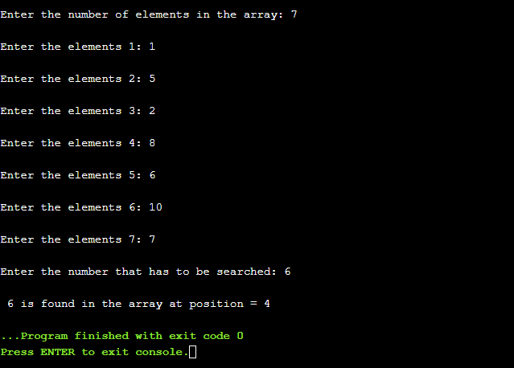

Ex. No.: 8(b) Date: 29/01/2021

PROGRAM NAME: Bubble Sort

AIM:

To Write a C Program to sort the 1D array elements using bubble sort.

ALGORITHM:

Step 1: Start

Step 2: Input array elements.

Step 3: Starting with the first element (index = 0), compare the current element with the next element of the array.
Step 4: If the current element is greater than the next element of the array, swap them.
Step 5: If the current element is less than the next element, move to the next element. Repeat Step 3 till all the array elements are sorted in ascending order.
Step 6: Print the sorted array elements.

Step 7: Stop

Program
#include <stdio.h>
int main()
{
int array[100], n, i, j, temp;
printf("Enter number of elements\n");
scanf("%d", &n);
printf("Enter %d integers\n", n);
for (i = 0; i < n; i++) {
scanf("%d", &array[i]);
}
for (i = 0 ; i < n - 1; i++) {
for (j = 0 ; j < n - i - 1; j++) {
if (array[j] > array[j+1]) {
temp = array[j];
array[j] = array[j+1];
array[j+1] = temp;
}
}
}
printf("Sorted list in ascending order:\n");
for (i = 0; i < n; i++) {
printf("%d\n", array[i]);
}
return 0;
}

Output
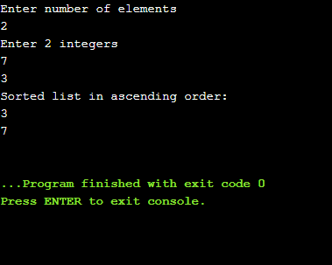

Ex. No.: 8(c) Date: 29/01/2021

PROGRAM NAME: Count The Number Of Persons Greater Than Average

Height

AIM:

To Write a C Program to populate an array with height of persons and find
how many persons are above the average height

ALGORITHM:

Step 1: Start

Step 2: Take the height of persons as input to an array.

Step 3: Using for loop calculate the sum of heights of N persons.

Step 4: At the exit of for loop calculate the average of heights of N persons.

Step 5: Compare average height with height of all the persons in the array, if height of a person is greater than the average height increment the counter value by one or else compare it with the next height.
Step 6: At the exit of the loop display the number of persons greater than the average height.
Step 7: Stop
Program
#include <stdio.h>
int main()
{
int array[100], i, n;
float avg = 0;
printf("Enter number of elements\n");
scanf("%d", &n);
printf("Enter %d integers\n", n);
for (i = 0; i < n; i++) {
scanf("%d", &array[i]);
avg += array[i];
}
avg = avg / n;
printf("Values More Than Avg Are: ");
for (int i = 0; i < n; i++)
if (array[i] > avg)
printf("%d, ", array[i]);
return 0;
}

Output
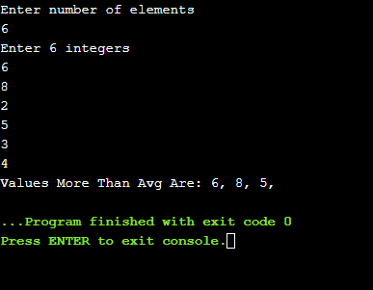
Result
Thus the C program was written and executed successfully for the following
- Perform linear search
- Sort the given numbers using bubble sort
- Populate an array with height of persons and find how many persons are above the average height.

C PROGRAMS USING TWO DIMENSIONAL ARRAY

Ex. No.: 9(a) Date: 05/02/2021

PROGRAM NAME: Add Two Matrices

AIM:

To Write a C Program to add 2D array matrix elements.

ALGORITHM:

Step 1: Start

Step 2: Input matrix 1 and matrix 2 elements.

Step 3: If the number of rows and number of columns of matrix 1 and matrix 2 are equal then execute Step 4 else print addition not possible

Step 4:

for i=1 to rows[matrix 1]

for j=1 to columns [matrix 1] Input matrix 1 [i,j]
Input matrix 2 [i,j]

matrix 3 [i,j]= matrix 1 [i,j] + matrix 2 [i,j];

Step 5: Display matrix 3 [i,j]

Step 6: Stop

Program
#include <stdio.h>
int main(){
int r, c, mat1[100][100], mat2[100][100], sum[100][100], i, j;
printf("\nEnter the number of rows and columns : ");
scanf("%d %d", &r, &c);
printf("\nInput Matrix 1 elements : ");
for(i=0; i<r; ++i) {
for(j=0; j<c; ++j) {
scanf("%d",&mat1[i][j]);
}
}

printf("\nInput Matrix 2 elements : ");
for(i=0; i<r; ++i) {
for(j=0; j<c; ++j) {
scanf("%d", &mat2[i][j]);
}
}
printf("\nAdded Matrix\n");
for(i=0;i<r;++i) {
for(j=0;j<c;++j) {
sum[i][j]=mat1[i][j]+mat2[i][j];
printf("%d\t",sum[i][j]);
}
printf("\n");
}
return 0;

}
Output
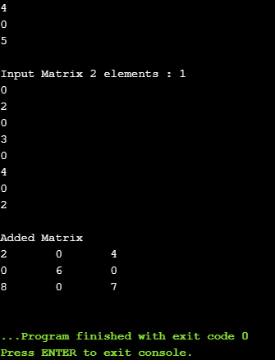

Ex. No.: 9(b) Date: 05/02/2021

PROGRAM NAME: Multiply Two Matrices

AIM:

To Write a C Program to multiply 2D array matrix elements.

ALGORITHM:

Step 1: Start

Step 2: Input matrix a and matrix b.

Step 3: Number of columns in the matrix a must be equal to the number of rows in the matrix b. If the condition true then executes Step 4 else print multiplication not possible

Step 4:

for i=1 to rows[matrix a]

for j=1 to columns [matrix b] for j=1 to columns [matrix b] Input matrix a [i,j]
Input matrix b [i,j]

matrix c [i,j]= matrix c[i,j] + matrix a [i,k] * matrix b [k,j];

Step 5: Display matrix c[i,j]

Step 6: Stop

Program

#include <stdio.h>
int main(){
int r, c, mat1[100][100], mat2[100][100], sum[100][100], i, j;
printf("\nEnter the number of rows and columns : ");
scanf("%d %d", &r, &c);
printf("\nInput Matrix 1 elements : ");
for(i=0; i<r; ++i) {
for(j=0; j<c; ++j) {
scanf("%d",&mat1[i][j]);
}
}

printf("\nInput Matrix 2 elements : ");
for(i=0; i<r; ++i) {
for(j=0; j<c; ++j) {
scanf("%d", &mat2[i][j]);
}
}
printf("\nMultiplication of Matrix\n");
for(i=0;i<r;++i) {
for(j=0;j<c;++j) {
sum[i][j]=0;
for(int k=0;k<r;k++) {
sum[i][j] = sum[i][j] + mat1[i][k] * mat2[k][j];
}
printf("%d\t",sum[i][j]);
}

printf("\n");
}
return 0;
}

Output
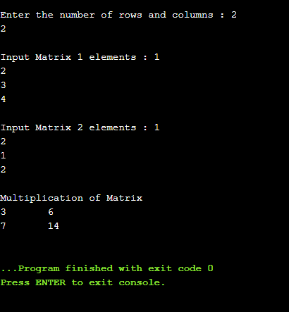

Ex. No.: 9(c)

Date: 05/02/2021

PROGRAM NAME: Sum Of Diagonal Elements Of A Matrix

AIM:

To Write a C Program to find Sum of diagonal elements of a matrix.

ALGORITHM:

Step 1: Start

Step 2: Input a matrix. for i=1 to rows[matrix a]
for j=1 to columns [matrix b] Input matrix[i,j]

Step 3:

for i=1 to rows[matrix a]

for j=1 to columns [matrix b] if i = = j then
sum=sum + matrix[i][j]

Step 4: Display sum of diagonal elements of a matrix.

Program
#include <stdio.h>
int main(){
int r, c, mat[100][100], i, j, sum = 0;
printf("\nEnter the number of rows and columns : ");
scanf("%d %d", &r, &c);
printf("\nEnter The Matrix elements : ");
for(i=0; i<r; ++i) {
for(j=0; j<c; ++j) {
scanf("%d",&mat[i][j]);
}
}

for(i=0;i<r;++i) {
sum = sum + mat[i][i];
}
printf("\n The Sum of Diagonal Elements of a Matrix = %d", sum );
return 0;
}

Output
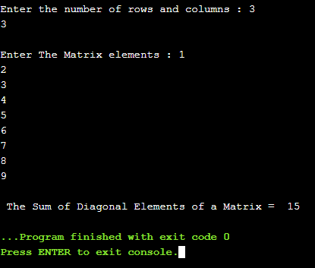

Result
Thus the C program was written and executed successfully for the following
- Add two matrices
- Multiply two matrices
- The sum of diagonal elements of a matrix

C PROGRAMS USING STRINGS

Ex. No.: 10(a) Date: 12/02/2021

PROGRAM NAME: Check Whether The Given String Is Palindrome Or Not

AIM:

To Write a C Program to Check whether the given string is palindrome or not.

ALGORITHM:

Step 1: Start

Step 2: Read the entered string using gets(s).

Step 3: Calculate the string length using string library function strlen(s) and store the length into the variable n.
Step 4: Set i=0,c=0 and Compare the element at s[i] with the element at s[n-i-1]. If both are equal then increase the c value.
Step 5: Compare the remaining characters by increasing i value up to i < n / 2.

Step 6: If the number of characters compared is equal to the number of characters matched then the given string is the palindrome.
Step 7: Stop

Program
#include <stdio.h>
void main() {
char string[25], reverse_string[25] = {'\0'};
int i, length = 0, flag = 0;

printf("Enter a string \n");
gets(string);
for (i = 0; string[i] != '\0'; i++)
{
length++;
}
printf("The length of the string '%s' = %d\n", string, length);
for (i = length - 1; i >= 0 ; i--)
{
reverse_string[length - i - 1] = string[i];
}
for (flag = 1, i = 0; i < length ; i++)
{
if (reverse_string[i] != string[i])
flag = 0;
}
if (flag == 1)
printf ("%s is a palindrome \n", string);
else
printf("%s is not a palindrome \n", string);
}

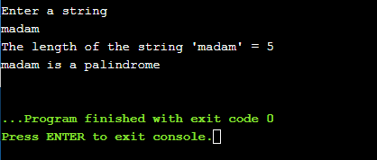
Output

Ex. No.: 10(b) Date: 12/02/2021

PROGRAM NAME: Perform The Following Using Built In Functions:

- Find the total number of words.

- Capitalize the first word of each sentence.

AIM:

To Write a C Program to find the total number of words and Capitalize the
firstword of each sentence.

ALGORITHM:

- Count total number of words Step 1: Start
Step 2: Read the entered string using gets(s). Step 3: Set wordcount value to zero
Step 4: Traverse the string until the termination null character (\0)

Step 5: While traversing the characters in an array if str[i]==' ' or str[i]=='\n' increment wordcount counter value by 1.
Step 6: At the exit of the loop print the wordcount counter value.

Step 7: Stop

Program

#include <stdio.h>
void main()
{
char s[200];
int count = 0, i;
printf("Enter the string:\n");
gets(s);
for (i = 0;s[i] != '\0';i++)
{
if (s[i] == ' ' && s[i+1] != ' ')
count++;
}
printf("Number of words in given string are: %d\n", count + 1);
}

Output
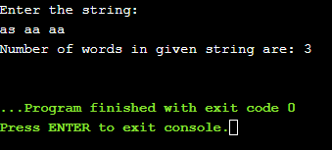

Ex. No.: 10(b) Date: 12/02/2021

ALGORITHM:

- Capitalize the first word of each sentence.

Step 1: Start

Step 2: Read the entered string using gets(s).

Step 3: Traverse the string until the termination null character (\0)

Step 4: Within the loop if index position is 0 then change lowercase case character into upper case character using str[i]=str[i]-32 or check for space character in the string and convert the immediate character after space into uppercase character.
Step 5: In a word if other than first character, if any character is in upper case then convert it into lower case character using str[i]=str[i]+32.
Step 6: At the exit of the loop print the string.

Step 7: Stop

Program
#include <stdio.h>
void main()
{
char s[200];
int count = 0, i;
printf("Enter the string:\n");
gets(s);
for (i = 0;s[i] != '\0';i++) {
if (s[i] == ' ')
break;
else
s[i] = toupper(s[i]);
}
printf("%s", s);
}
Output
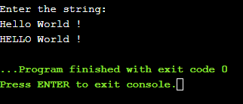

Result
Thus the C program was written and executed successfully for the following
- Find the total number of words
- Check whether given string is palindrome or not without using built-in function
- Capitalize the first word in a sentence

C PROGRAMS USING FUNCTIONS

Ex. No.: 11(a) Date: 18/02/2021

Arithmetic Calculator

AIM:

To write a C program to perform basic arithmetic operations using
functions.

ALGORITHM:

Step 1: Start

Step 2: Input two numbers and a character from user in the given format. Store them in some variable num1, num2 and op.
Step 3: Switch the value of op i.e. switch(op). There are four possible values of op i.e. '+', '-', '*' and '/'.
Step 4: For case '+' call addition function and return the result to main. In main function store the returned value in some variable.
Step 5: Repeat the process for subtraction, multiplication and division.

Step 6: Finally print the value of result.

Step 7: Stop

Program
#include<stdio.h>
int main() {
char cla;
int a, b, r;
printf("Enter an operator (+, -, *,): ");
scanf("%c", &cla);
printf("Enter The Number 1 and 2: ");
scanf("%d %d", &a, &b);
switch(cla) {
case '+':
r = add(a, b);
break;
case '-':
r = sub(a, b);
break;
case '*':
r = multi(a, b);
break;
case '/':
r = div(a, b);
break;
default:
printf("You Have Enter Wrong operator");
}
if(r) {
printf("%d %c %d = %d", a, cla, b, r);
}
return 0;
}
int add(int a, int b) {
return a + b;
}
int sub(int a, int b) {
return a + b;
}
int multi(int a, int b) {
return a + b;
}
int div(int a, int b) {
return a + b;
}
Output
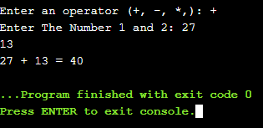

Ex. No.: 11(b) Date: 18/02/2021

PROGRAM NAME: Sorting N Numbers

AIM:

To write a C program to sort the list of numbers using functions.

ALGORITHM:

Step 1: Start

Step 2: Read the size of the array and store the value into the variable n.

Step 3: Read the entered elements one by one and store the elements in the array a[] using for loop.
Step 4: call the user defined function asc_sort()

Step 5: In the asc_sort( ) function arrange the array elements from least to highest value as for loop iterates from i=0 to i<n-1.
Step 7: Compare a[j] element with adjacent element a[j+1] and find the highest element then exchange the both elements positions using for loop.
Step 8: After all iterations of for loop, we will get sorted array in which the elements are in ascending order. Print the array elements using the for loop in the main function.
Step 9: Stop
Program
#include <stdio.h>
int main() {
int i, j, temp, n, number[30];
printf("Enter the value of N: \n");
scanf("%d", &n);

printf("Enter the numbers: \n");
for (i = 0; i < n; ++i)
scanf("%d", &number[i]);
sort_numbers_ascending(n, number);
return 0;
}
int sort_numbers_ascending(int n, int number[]) {
int temp, i, j;
for (i = 0; i <= n; ++i) {
for (j = i + 1; j < n; ++j) {
if (number[i] > number[j]) {
temp = number[i];
number[i] = number[j];
number[j] = temp;
}
}
}
printf("The numbers arranged in ascending order are given below: \n");
for (i = 0; i < n; ++i)
printf("%d\n", number[i]);
}

Output
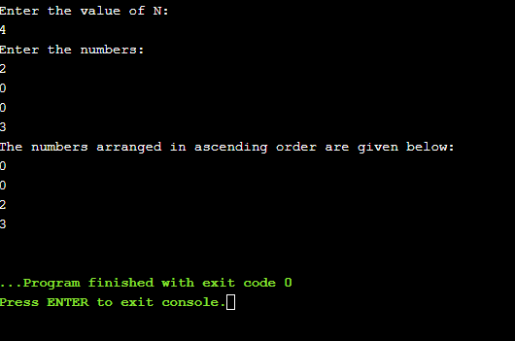
Result
Thus the C program was written and executed successfully for the following
- Arithmetic Operations Using Functions.
- Sort the list of numbers

C PROGRAMS USING RECURSION

Ex. No.: 12(a) Date: 18/02/2021

PROGRAM NAME:Find The Factorial Of A Number Using Recursion

AIM:

To write a C program to find the factorial of a number using recursion.

ALGORITHM:

Step 1: Start

Step 2: Read number num

Step 3: Call fact(num)

Step 4: Print factorial of a given number

Step 5: Stop

ALGORITHM FOR FUNCTION fact(n):

Step 1: If n==1 then return 1

Step 2: Else

f=n*fact(n-1)

Step 3: Return f to main function

Program
#include<stdio.h>
int main() {
int n;
printf("Enter a integer: ");
scanf("%d",&n);
printf("Factorial of %d = %ld", n, factorial(n));
return 0;
}

int factorial(int n) {
if (n>=1)
return n*factorial(n-1);
else
return 1;
}
Output
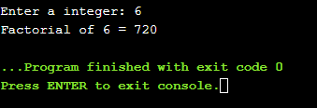

Ex. No.: 12(b) Date: 18/02/2021

PROGRAM NAME: Generate Fibonacci Series Using Recursion

AIM:

To write a C program to generate Fibonacci series using recursion.

ALGORITHM:

Step 1: Start

Step 2: Read number of Fibonacci terms to be generated in n

Step 3: Call Fibanocci(num) Step 4: Print the Fibonacci series Step 5: Stop

ALGORITHM FOR FUNCTION Fibanocci(n):

Step 1: If num == 0 then return 0. Since Fibonacci of 0th term is 0.

Step 2: If num == 1 then return 1. Since Fibonacci of 1st term is 1.

Step 3: If num > 1 then return fibo(num - 1) + fibo(n-2). Since Fibonacci of a term is sum of previous two terms.
Program
#include<stdio.h>
int fib(int n) {
if (n <= 1)
return n;
return fib(n-1) + fib(n-2);
}
int main () {
int n;
printf("Enter a integer: ");
scanf("%d",&n);
printf("%d", fib(n));
return 0;
}
Output
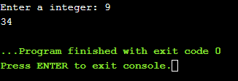
Result
Thus the C program was written and executed successfully for the following
- Find the factorial of a number using recursion
- Generate Fibonacci series using recursion

C PROGRAMS USING POINTERS

Ex. No.: 13(a) Date: 20/02/2021

PROGRAM NAME: Swap The Value Of Two Numbers Using Call By Value And

Call By Reference

AIM:

To write a C program swap the value of two numbers using call by value and call by reference

ALGORITHM:

- Swap two numbers using call by Value Step 1: Start
Step 2: Input the values for a and b

Step 3: Call the function swap(&x,&y) Step 3a: Start the function swap Step 3b: Assign temp= *x
Step 3c: Assign *x = *y Step 3d: Assign *y = temp Step 3e: End function
Step 4: Print the value of a and b values in main function

Step 5: Stop

Program
#include <stdio.h>
int main() {
int a, b;
printf("Enter Value of x: ");
scanf("%d", &a);
printf("\nEnter Value of y: ");
scanf("%d", &b);
printf("a=%d b=%d\n", a, b);
swapx(a, b);
return 0;
}
int swapx(int x, int y) {
int t;
t = x;
x = y;
y = t;
printf("x=%d y=%d\n", x, y);
}
Output
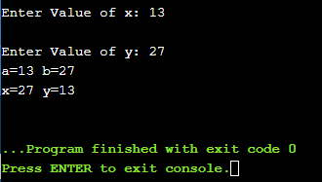

Ex. No.: 13(a) Date: 20/02/2021

ALGORITHM:

- Swap two numbers using call by Reference Step 1: Start
Step 2: Input the values for a and b

Step 3: Call the function swap(&x,&y) Step 3a: Start the function swap Step 3b: Assign temp= *x
Step 3c: Assign *x = *y Step 3d: Assign *y = temp Step 3e: End function
Step 4: Print a and b values in main function

Step 5: Stop

#include <stdio.h>
int main() {
int a, b;
printf("Enter Value of x: ");
scanf("%d", &a);
printf("\nEnter Value of y: ");
scanf("%d", &b);
printf("a=%d b=%d\n", a, b);
swapx(&a, &b);
return 0;
}
int swapx(int* x, int* y) {
int t;
t = *x;
*x = *y;
*y = t;
printf("x=%d y=%d\n", *x, *y);
}

Output
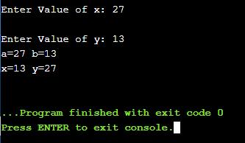

Result
Thus the C program was written and executed successfully for the following
- Swap the value of two numbers using call by value
- Swap the value of two numbers using call by reference

Ex. No.: 13(b) Date: 20/02/2021

PROGRAM NAME: Sort A List Of Names Using Pointers

AIM:

To write a C program to sort a list of names using pointers.

ALGORITHM:

Step 1: Start

Step 2: Get number of strings as input from user in n

Step 3: Character array pointer type variable acquires the memory using malloc() function
Step 4: Call reorder(n,x)

Step 4.1: Traverse the Character array and compare the two consecutive strings using strcmp(x[i],x[j])>0 and if the condition is true then swap two strings.
Step 4.2: if strcmp(x[i],x[j])>0 is false then no need to swap the strings.

Step 5: Then traverse the character array and print the reordered strings in main()

Step 6: Stop

Program
#include<stdio.h>
#include<string.h>
int main() {
char *x[20];
int i, n=0;
int reorder(int n,char *x[]);
printf("Enter no. of String : ");
scanf("%d",&n);
printf("\n");
for(i=0;i<n;i++) {
printf("Enter the Strings %d : ",i+1);
x[i]=(char *)malloc(20*sizeof(char));
scanf("%s",x[i]);
}
reorder(n,x);
printf("\nreorder list is : \n");
for(i=0;i<n;i++) {
printf("%d %s\n",i+1,x[i]);
}
}
int reorder(int n,char *x[]) {
int i,j;
char t[20];
for(i=0;i<n-1;i++)
for(j=i+1;j<n;j++)
if(strcmp(x[i],x[j])>0) {
strcpy(t,x[j]);
strcpy(x[j],x[i]);
strcpy(x[i],t);
}
return;
}
Output
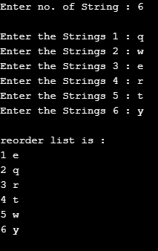

Result
Thus the C program was written and executed successfully for Sort a list of names using pointers

C PROGRAMS USING STRUCTURES

Ex. No.: 14(a) Date: 22/02/2021

PROGRAM NAME: To Compute Internal Marks Of Students For Five

Different Subjects

AIM:

To write a C program to compute internal marks of students for five
different subjects using structures.

ALGORITHM:

Step 1: Start

Step 2: Define a structure student using struct keyword.

Step 3: Create structure variables name, rollnumber and average marks within a structure.
Step 4: Create a variable for structure using as array of structures.

Step 5: Using the structure variable assign values for the variables within the structure.
Step 6: Display the students record of name, roll number and average marks using structure variable and .dot operator (eg: s.name)
Step 7: Stop

Program
#include<stdio.h>
#include<stdlib.h>
struct student {
int f, s, t, total, avg, internal, assignment;
};
struct student s[10], s2[10], s3[10], s4[10], s5[10];
int main() {
int n, i;
printf("Enter Number Of Students: ");
scanf("%d", &n);
for(i = 0; i < n; i++) {
printf("\t\tEnter Mark For English\t\t\n");
printf("Enter 3 Cycle Test Mark (Max: 100 Mark): ");
scanf("%d %d %d", &s[i].f, &s[i].s, &s[i].t);
s[i].total = s[i].f + s[i].s + s[i].t;
s[i].avg = s[i].total/3;
printf("Enter Assignment Mark (Max: 10 Mark): ");
scanf("%d", &s[i].assignment);
s[i].internal = (s[i].avg * 0.3) + (s[i].assignment*01);

printf("\t\tEnter Mark For Maths\t\t\n");
printf("Enter 3 Cycle Test Mark (Max: 100 Mark): ");
scanf("%d %d %d", &s2[i].f, &s2[i].s, &s2[i].t);
s2[i].total = s2[i].f + s2[i].s + s2[i].t;
s2[i].avg = s2[i].total/3;
printf("Enter Assignment Mark (Max: 10 Mark): ");
scanf("%d", &s2[i].assignment);

s2[i].internal = (s2[i].avg * 0.3) + (s2[i].assignment*01);

printf("\t\tEnter Mark For Physics\t\t\n");
printf("Enter 3 Cycle Test Mark (Max: 100 Mark): ");
scanf("%d %d %d", &s3[i].f, &s3[i].s, &s3[i].t);
s3[i].total = s3[i].f + s3[i].s + s3[i].t;
s3[i].avg = s3[i].total/3;
printf("Enter Assignment Mark (Max: 10 Mark): ");
scanf("%d", &s3[i].assignment);
s3[i].internal = (s3[i].avg * 0.3) + (s3[i].assignment*01);

printf("\t\tEnter Mark For Chemistry\t\t\n");
printf("Enter 3 Cycle Test Mark (Max: 100 Mark): ");
scanf("%d %d %d", &s4[i].f, &s4[i].s, &s4[i].t);
s4[i].total = s4[i].f + s4[i].s + s4[i].t;
s4[i].avg = s4[i].total/3;
printf("Enter Assignment Mark (Max: 10 Mark): ");
scanf("%d", &s4[i].assignment);
s4[i].internal = (s4[i].avg * 0.3) + (s4[i].assignment*01);

printf("\t\tEnter Mark For CS\t\t\n");
printf("Enter 3 Cycle Test Mark (Max: 100 Mark): ");
scanf("%d %d %d", &s5[i].f, &s5[i].s, &s5[i].t);
s5[i].total = s5[i].f + s5[i].s + s5[i].t;
s5[i].avg = s5[i].total/3;
printf("Enter Assignment Mark (Max: 10 Mark): ");
scanf("%d", &s5[i].assignment);
s5[i].internal = (s5[i].avg * 0.3) + (s5[i].assignment*01);

}
for(i = 0; i < n; i++) {
printf("Student %d Got %d Marks in Engilish %d Marks in Maths %d Marks in Physics %d Marks in Chemistry %d Marks in CS \n", i+1, s[i].internal, s2[i].internal, s3[i].internal, s4[i].internal, s5[i].internal);
}
}
Output
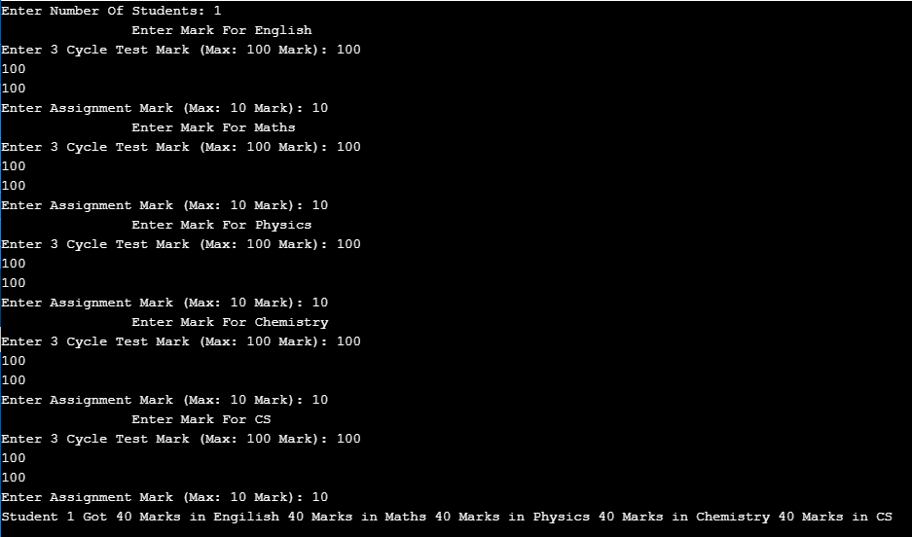
Result
Thus the C program to compute internal marks of students for five subjects using
structure was executed successfully.

C PROGRAMS USING FILES

Ex. No.: 15(a) Date: 25/02/2021

PROGRAM NAME: To Compute Internal Marks Of Students For Five

Different Subjects

AIM:

To write a C program to compute internal marks of students for five
different subjects using files.

ALGORITHM:

Step 1: Start

Step 2: Declare a file pointer variable using FILE *filepointer.

Step 3: Open a file using fopen() function in read, write or append mode and it returns the starting address of a file store it in file pointer location for further file processing.
Step 4: Get input from the file to the program using fscanf() and write the output onto the file using fprintf().
Step 5: Close the file using fclose(filepointer).

Step 6: Stop

Program
#include<stdio.h>
#include<stdlib.h>
struct student {
int f, s, t, total, avg, internal, assignment;
};
struct student s[10], s2[10], s3[10], s4[10], s5[10];
int main() {
int n, i;
FILE *fp;
printf("Enter Number Of Students: ");
scanf("%d", &n);
fp = fopen("file.txt", "w");
for(i = 0; i < n; i++) {
printf("\t\tEnter Mark For English\t\t\n");
printf("Enter 3 Cycle Test Mark (Max: 100 Mark): ");
scanf("%d %d %d", &s[i].f, &s[i].s, &s[i].t);
s[i].total = s[i].f + s[i].s + s[i].t;
s[i].avg = s[i].total/3;
printf("Enter Assignment Mark (Max: 10 Mark): ");
scanf("%d", &s[i].assignment);
s[i].internal = (s[i].avg * 0.3) + (s[i].assignment*01);
fprintf(fp, "\t\tEnter Mark For English\t\t\nEnter 3 Cycle Test Mark (Max: 100 Mark): \n%d\n%d\n%d\nTotal Mark: %d\nAverage: %d\Enter Assignment Mark (Max: 10 Mark): %d\nTotal Internal Mark: %d", s[i].f, s[i].s, s[i].t, s[i].total, s[i].avg, s[i].assignment, s[i].internal);
fprintf(fp, "\n");

printf("\t\tEnter Mark For Maths\t\t\n");
printf("Enter 3 Cycle Test Mark (Max: 100 Mark): ");
scanf("%d %d %d", &s2[i].f, &s2[i].s, &s2[i].t);
s2[i].total = s2[i].f + s2[i].s + s2[i].t;
s2[i].avg = s2[i].total/3;
printf("Enter Assignment Mark (Max: 10 Mark): ");
scanf("%d", &s2[i].assignment);
s2[i].internal = (s2[i].avg * 0.3) + (s2[i].assignment*01);
fprintf(fp, "\t\tEnter Mark For Maths\t\t\nEnter 3 Cycle Test Mark (Max: 100 Mark): \n%d\n%d\n%d\nTotal Mark: %d\nAverage: %d\Enter Assignment Mark (Max: 10 Mark): %d\nTotal Internal Mark: %d", s2[i].f, s2[i].s, s2[i].t, s2[i].total, s2[i].avg, s2[i].assignment, s2[i].internal);
fprintf(fp, "\n");

printf("\t\tEnter Mark For Physics\t\t\n");
printf("Enter 3 Cycle Test Mark (Max: 100 Mark): ");
scanf("%d %d %d", &s3[i].f, &s3[i].s, &s3[i].t);
s3[i].total = s3[i].f + s3[i].s + s3[i].t;
s3[i].avg = s3[i].total/3;
printf("Enter Assignment Mark (Max: 10 Mark): ");
scanf("%d", &s3[i].assignment);
s3[i].internal = (s3[i].avg * 0.3) + (s3[i].assignment*01);
fprintf(fp, "\t\tEnter Mark For Physics\t\t\nEnter 3 Cycle Test Mark (Max: 100 Mark): \n%d\n%d\n%d\nTotal Mark: %d\nAverage: %d\Enter Assignment Mark (Max: 10 Mark): %d\nTotal Internal Mark: %d", s3[i].f, s3[i].s, s3[i].t, s3[i].total, s3[i].avg, s3[i].assignment, s3[i].internal);
fprintf(fp, "\n");

printf("\t\tEnter Mark For Chemistry\t\t\n");
printf("Enter 3 Cycle Test Mark (Max: 100 Mark): ");
scanf("%d %d %d", &s4[i].f, &s4[i].s, &s4[i].t);
s4[i].total = s4[i].f + s4[i].s + s4[i].t;
s4[i].avg = s4[i].total/3;
printf("Enter Assignment Mark (Max: 10 Mark): ");
scanf("%d", &s4[i].assignment);
s4[i].internal = (s4[i].avg * 0.3) + (s4[i].assignment*01);
fprintf(fp, "\t\tEnter Mark For Chemistry\t\t\nEnter 3 Cycle Test Mark (Max: 100 Mark): \n%d\n%d\n%d\nTotal Mark: %d\nAverage: %d\Enter Assignment Mark (Max: 10 Mark): %d\nTotal Internal Mark: %d", s4[i].f, s4[i].s, s4[i].t, s4[i].total, s4[i].avg, s4[i].assignment, s4[i].internal);
fprintf(fp, "\n");

printf("\t\tEnter Mark For CS\t\t\n");
printf("Enter 3 Cycle Test Mark (Max: 100 Mark): ");
scanf("%d %d %d", &s5[i].f, &s5[i].s, &s5[i].t);
s5[i].total = s5[i].f + s5[i].s + s5[i].t;
s5[i].avg = s5[i].total/3;
printf("Enter Assignment Mark (Max: 10 Mark): ");
scanf("%d", &s5[i].assignment);
s5[i].internal = (s5[i].avg * 0.3) + (s5[i].assignment*01);
fprintf(fp, "\t\tEnter Mark For CS\t\t\nEnter 3 Cycle Test Mark (Max: 100 Mark): \n%d\n%d\n%d\nTotal Mark: %d\nAverage: %d\Enter Assignment Mark (Max: 10 Mark): %d\nTotal Internal Mark: %d", s5[i].f, s5[i].s, s5[i].t, s5[i].total, s5[i].avg, s5[i].assignment, s5[i].internal);
fprintf(fp, "\n");
}
for(i = 0; i < n; i++) {
printf("Student %d Got %d Marks in Engilish %d Marks in Maths %d Marks in Physics %d Marks in Chemistry %d Marks in CS \n", i, s[i].internal, s2[i].internal, s3[i].internal, s4[i].internal, s5[i].internal);
fprintf(fp, "Student %d Got %d Marks in Engilish %d Marks in Maths %d Marks in Physics %d Marks in Chemistry %d Marks in CS \n", i, s[i].internal, s2[i].internal, s3[i].internal, s4[i].internal, s5[i].internal);
}
fclose(fp);
}
Output
Result
Thus the C program to compute internal marks of students for five subjects using
files was executed successfully.

CONTENT BEYOND SYLLABUS

AIM:
The objective of the puzzle is to move the entire stack to another rod, obeying the following simple rules:

  - Only one disk can be moved at a time.
  - Each move consists of taking the upper disk from one of the stacks and placing it on top of another stack i.e. a disk can only be moved if it is the uppermost disk on a stack.
  - No disk may be placed on top of a smaller disk.

Algorithm Step 1: Start
Step 2: Declare a tower_of_hanoi recursive function and pass two arguments: the number of disks n and the name of the rods such as source, temp, and target.

Step 3: Check the base case when the number of disks is one .If it is true goto Step 4 else goto Step 5

Step 4: Simply move the one disk from the source to target and return.

Step 5: Recursively move remaining n-1 disks from source to temp using the target as the temp.

Step 6: Change the remaining one disk move on the source to target.

Step 7: Move the n-1 disks on the temp to the target using the source as the temp.

Step 8: Stop.

Program
#include<stdio.h>
int towerOfHanoi(int n, char from_rod, char to_rod, char aux_rod) {
if (n == 1) {
printf("\nMove disk 1 from rod %c to rod %c", from_rod, to_rod);
return;

}
towerOfHanoi(n-1, from_rod, aux_rod, to_rod);
printf("\nMove disk %d from rod %c to rod %c", n, from_rod, to_rod);
towerOfHanoi(n-1, aux_rod, to_rod, from_rod);
return;
}
int main() {
int n;
printf("Enter Number Of disk: ");
scanf("%d", &n);
towerOfHanoi(n, 'A', 'C', 'B');
return 0;
}
Output
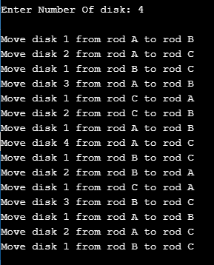

Result
Thus the C program for tower of hanoi using recursion was executed successfully.

